CSA1402 COMPILER DESIGN
C01 AT2 ERROR ANALYSIS
GAUTHAM B (192421318)

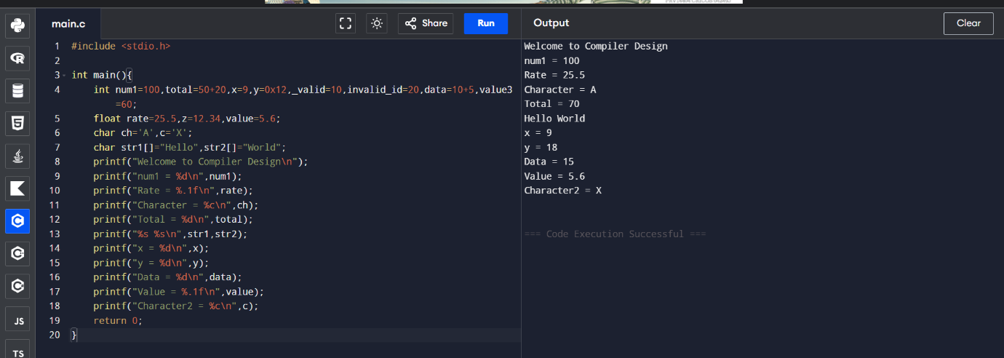
1

2
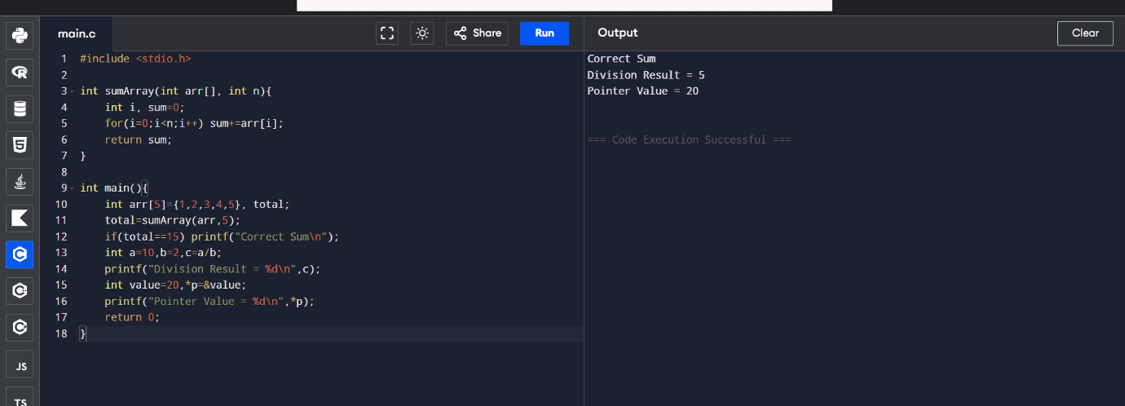
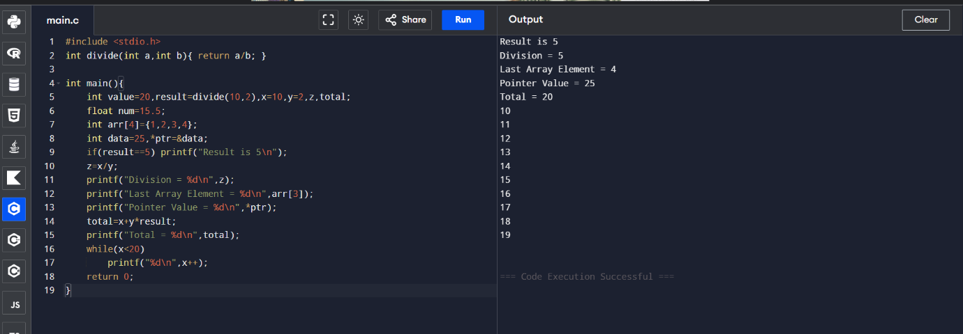
3

